Ben Brandhorst
06/01/2019
SDEV 300 6380
Building Secure Web Applications

Web Page Foundations

Rocket Stationary Main Page
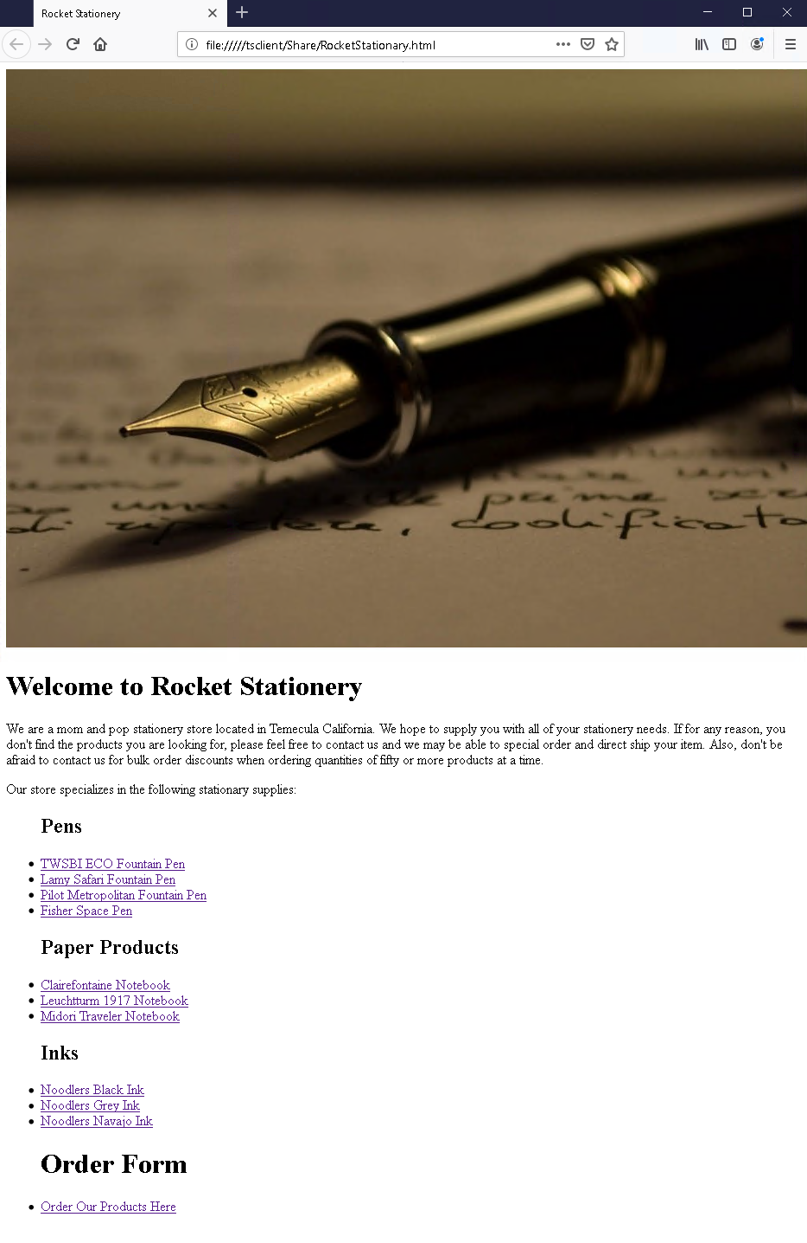

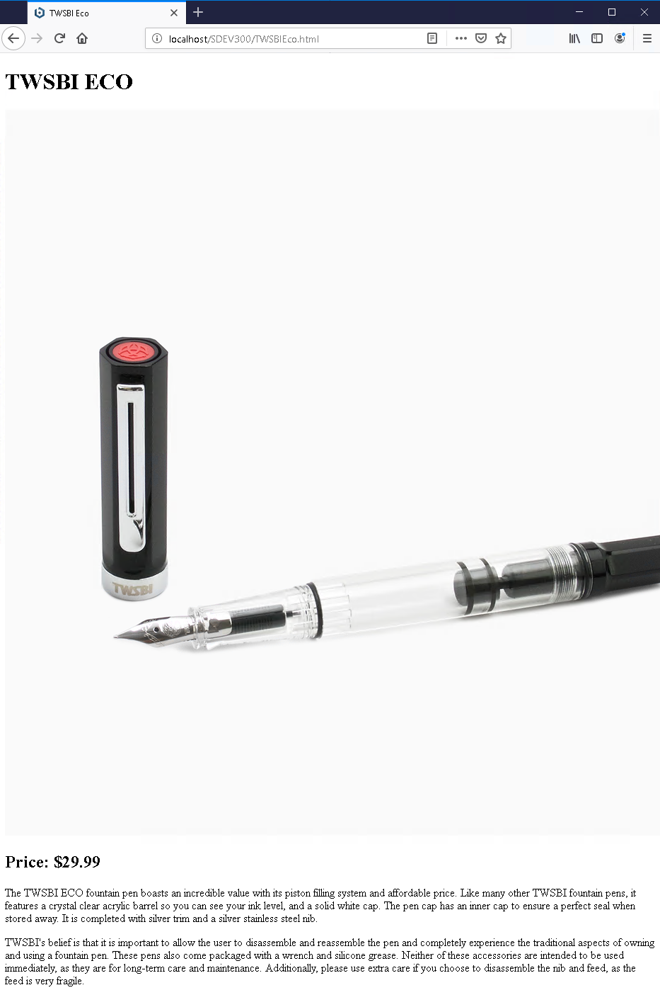
TWSBI ECO Page
Lamy Safari Page
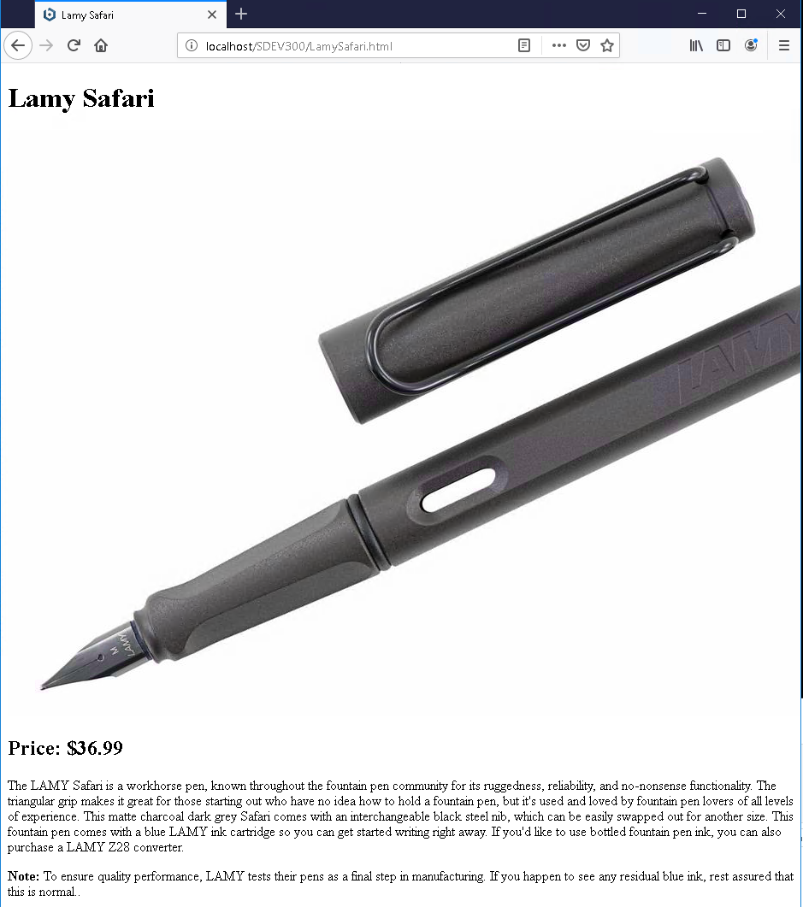

Pilot Metropolitan Page
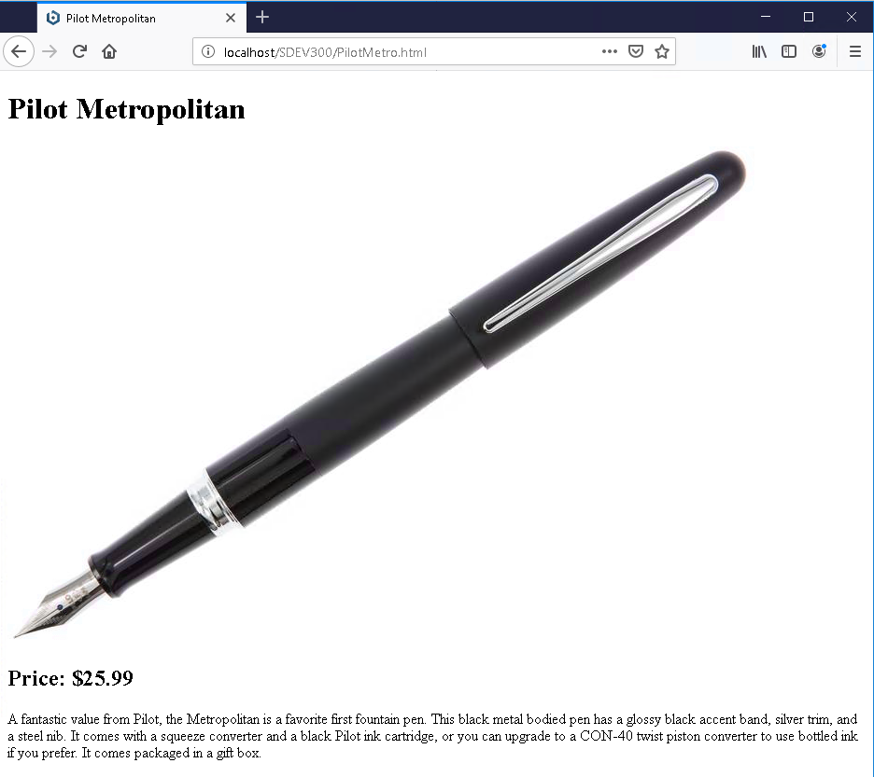

Fisher Space Pen Page
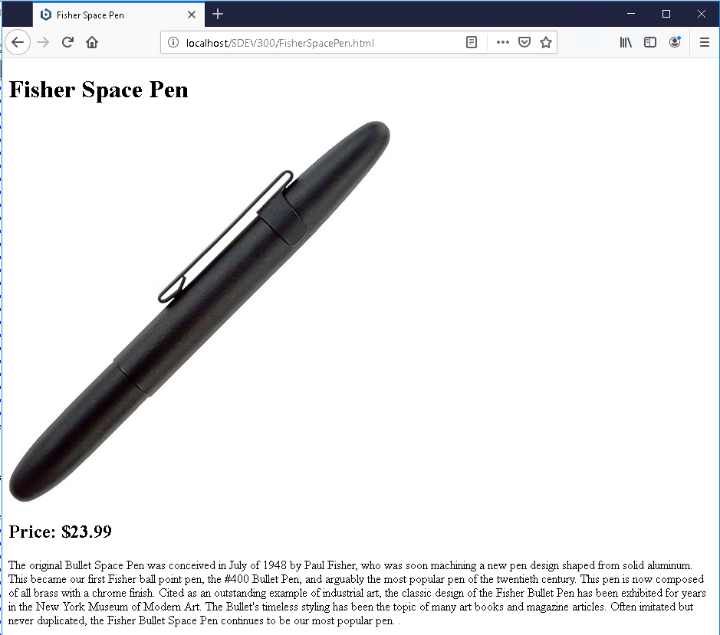

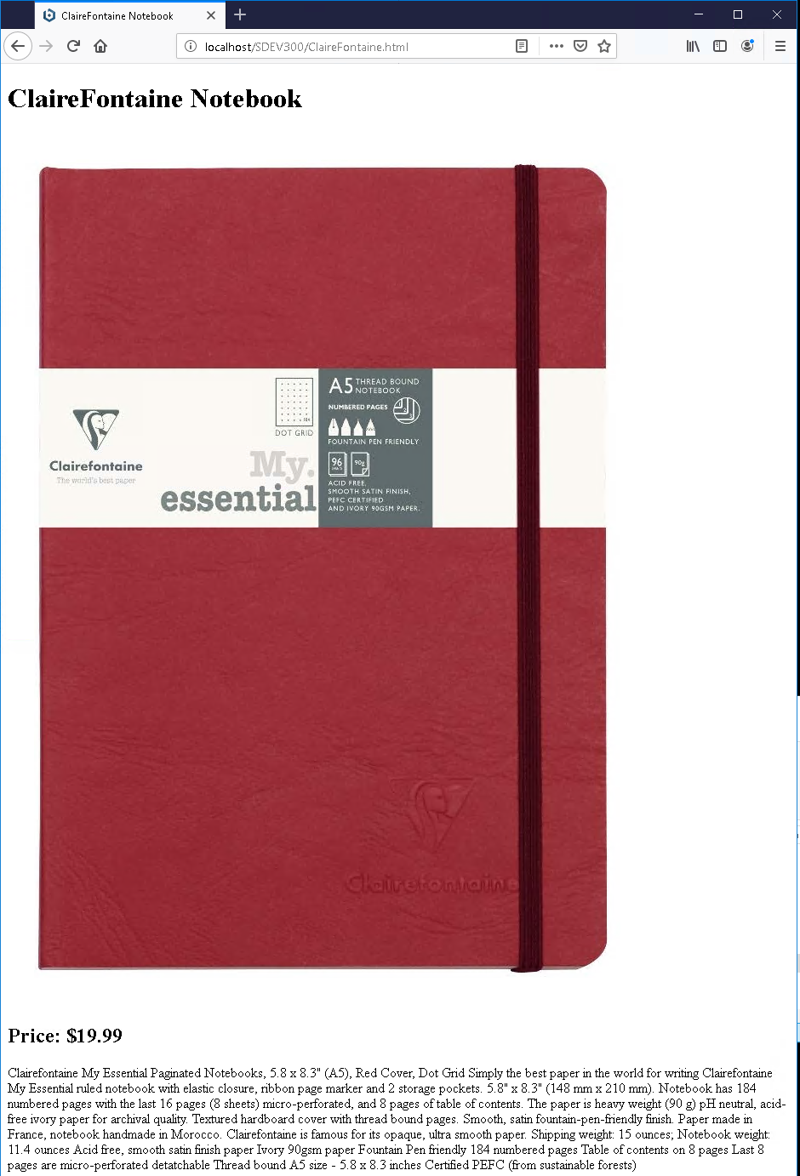
Clairefontaine Notebook Page
Leuchtturm 1917 Journal Page
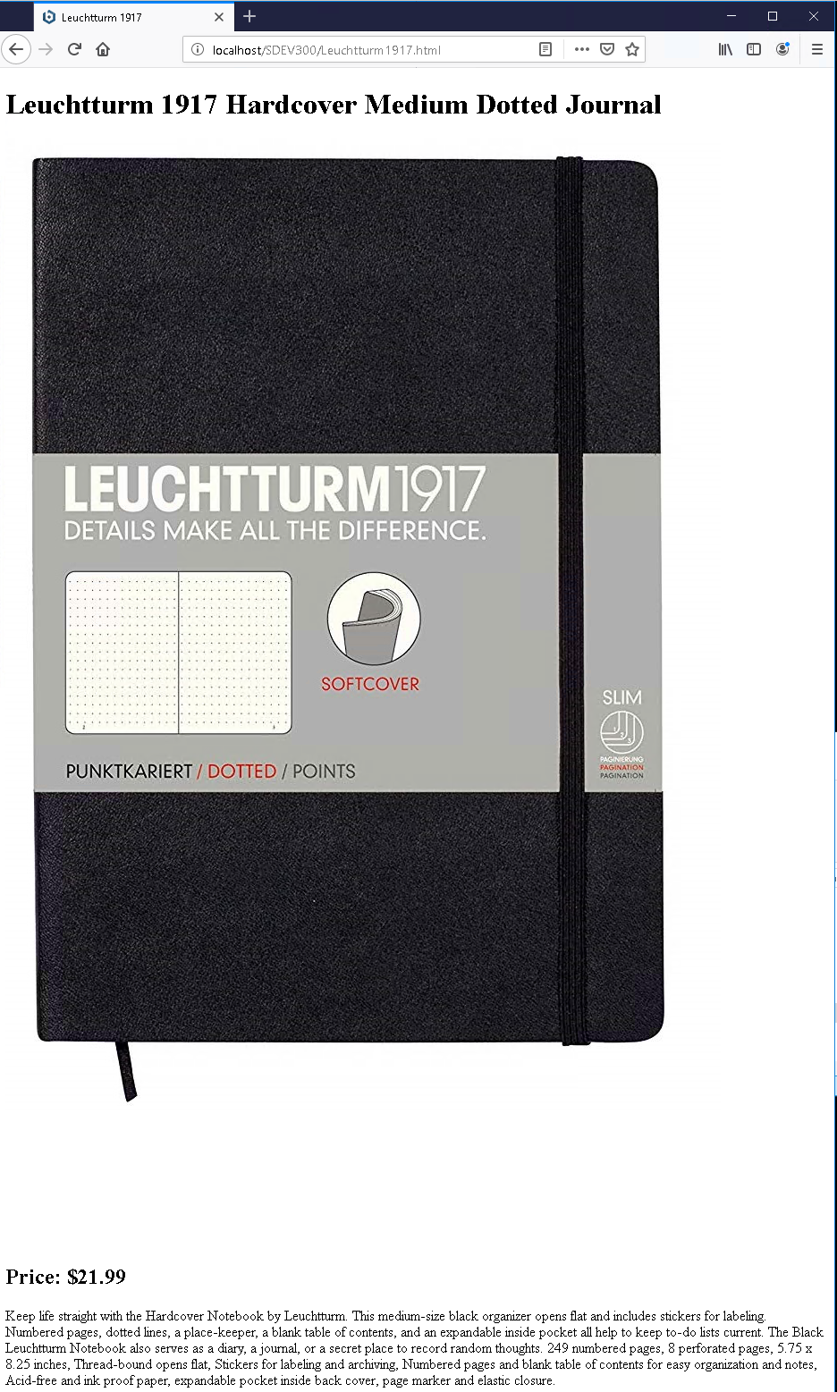

Midori Traveler’s Notebook Page
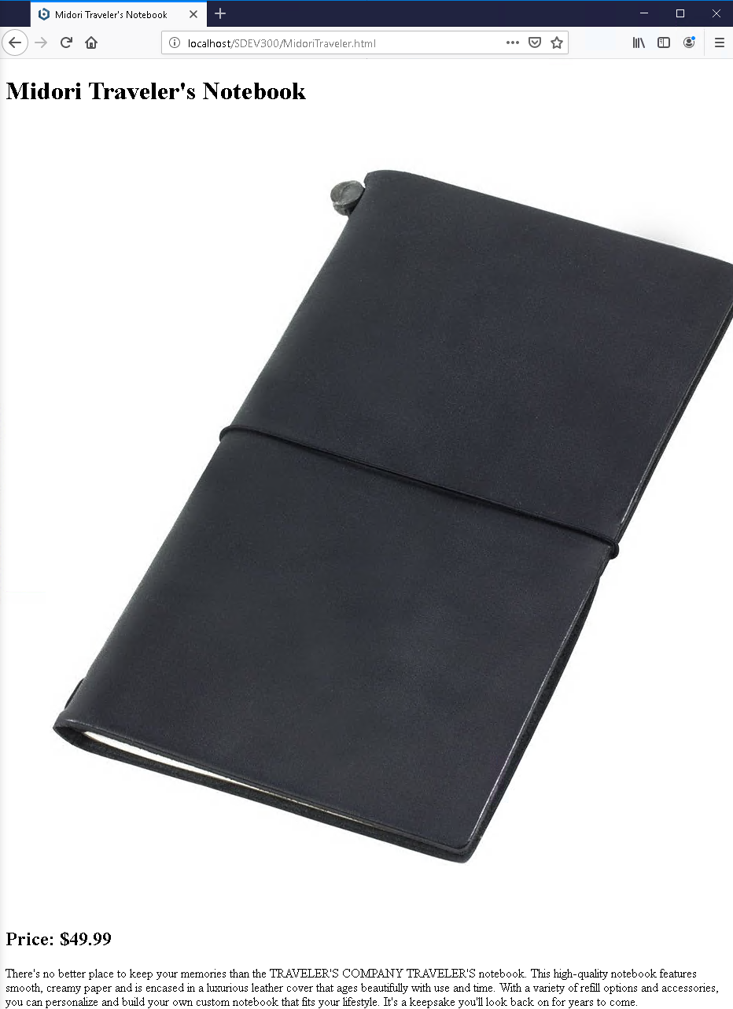
Noodler’s Black Ink Page
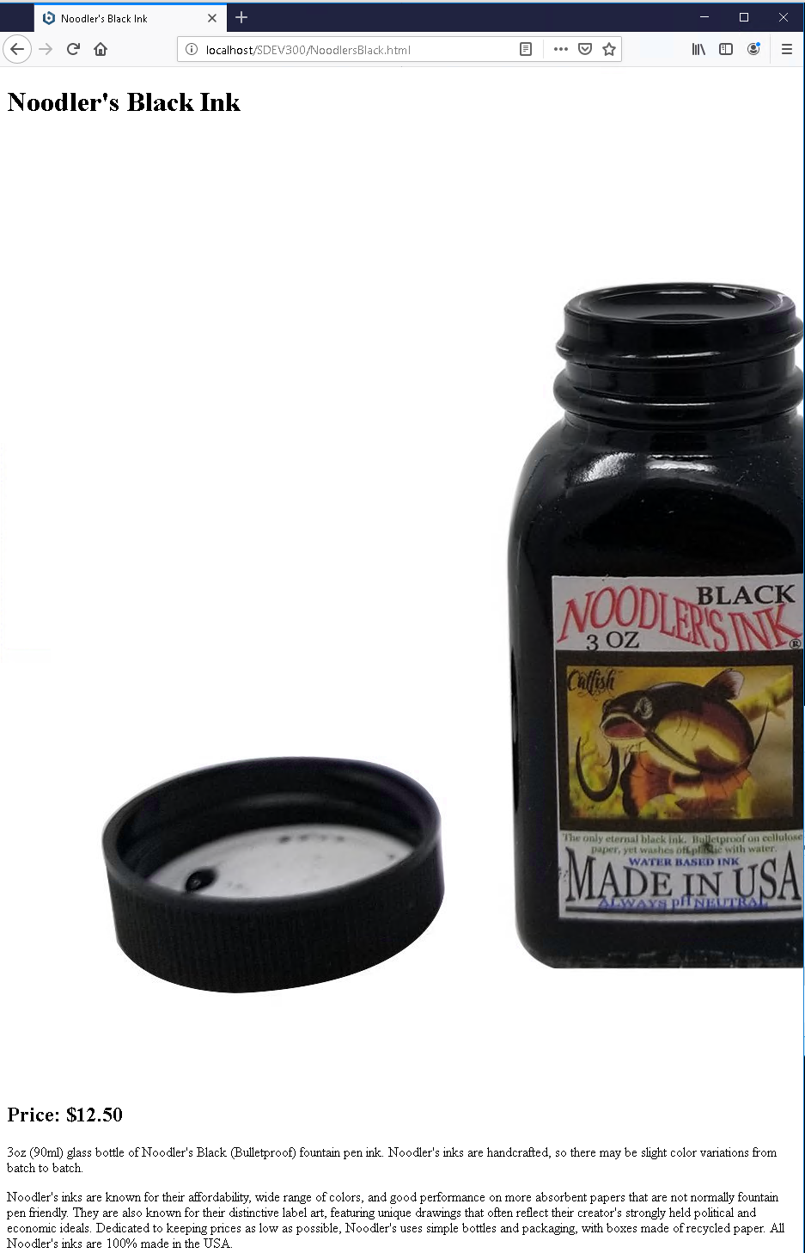

Noodler’s Grey Ink Page
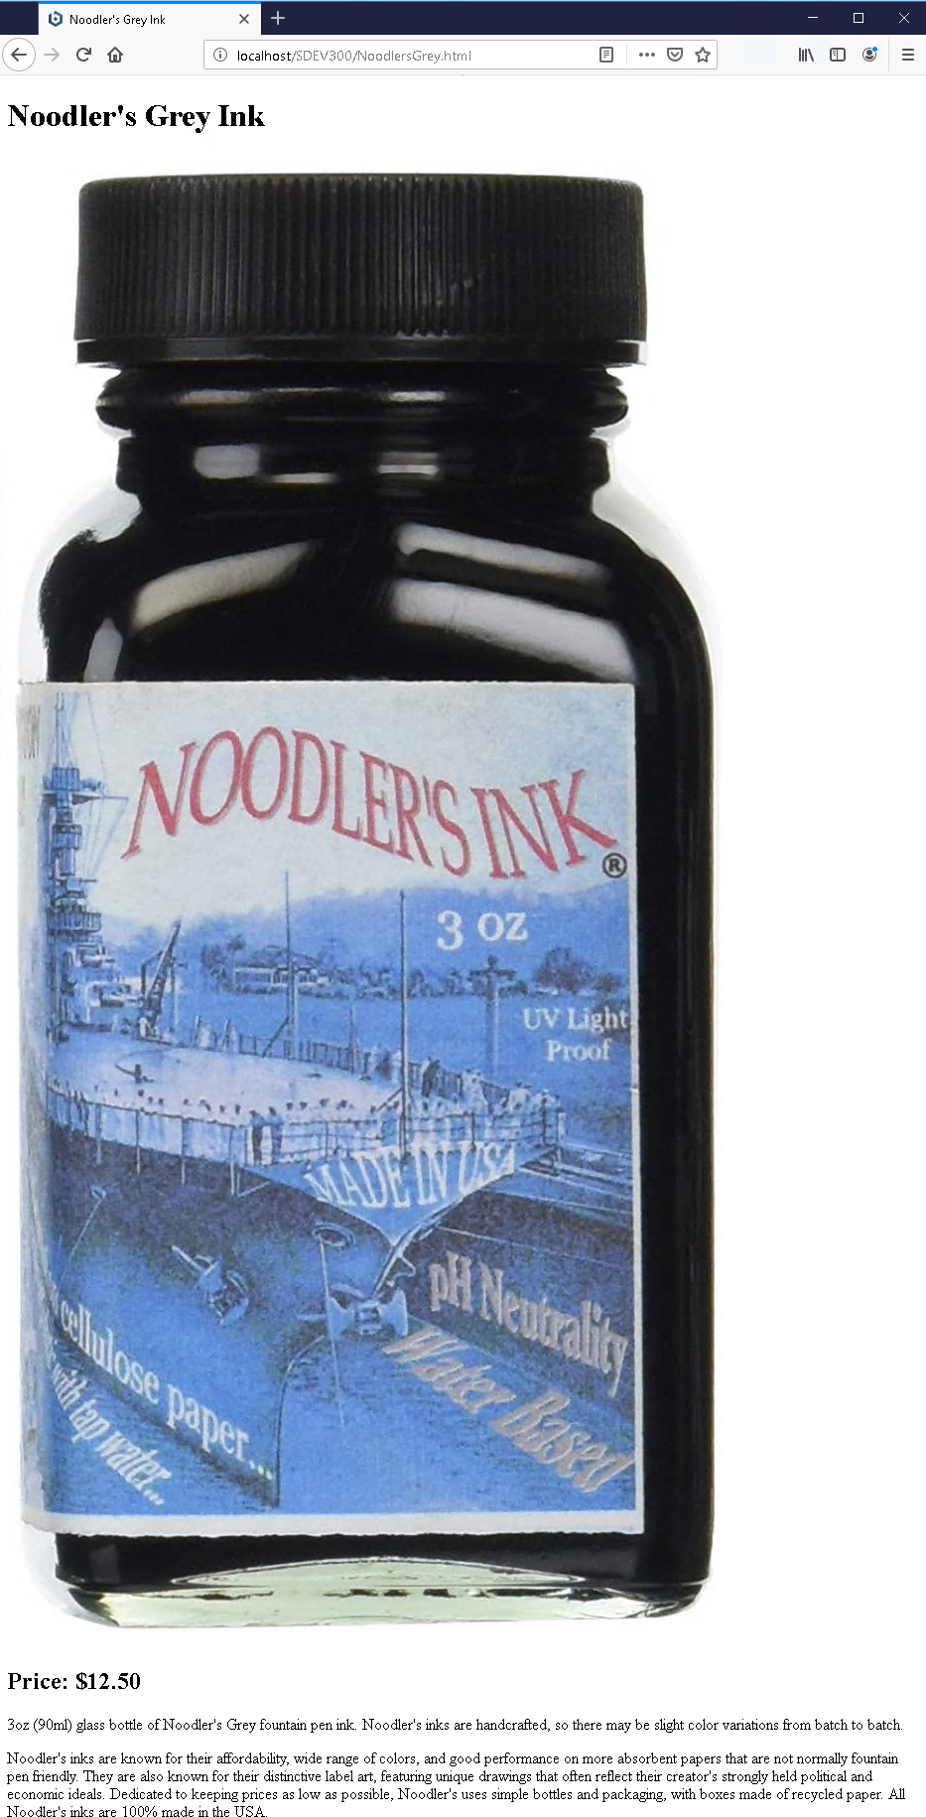

Noodler’s Navajo Ink Page
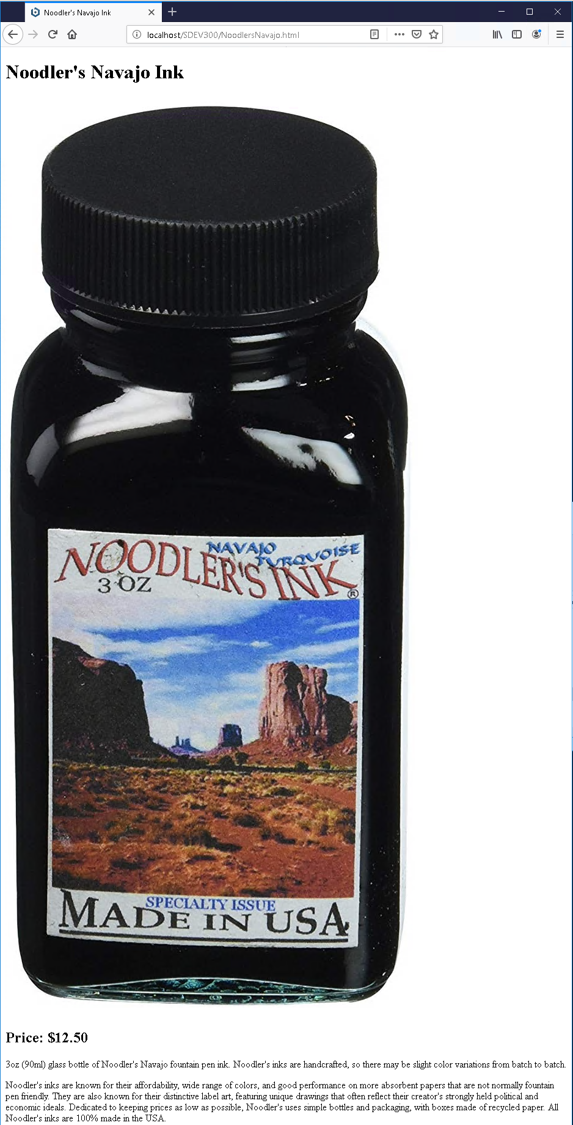

Order Form Page
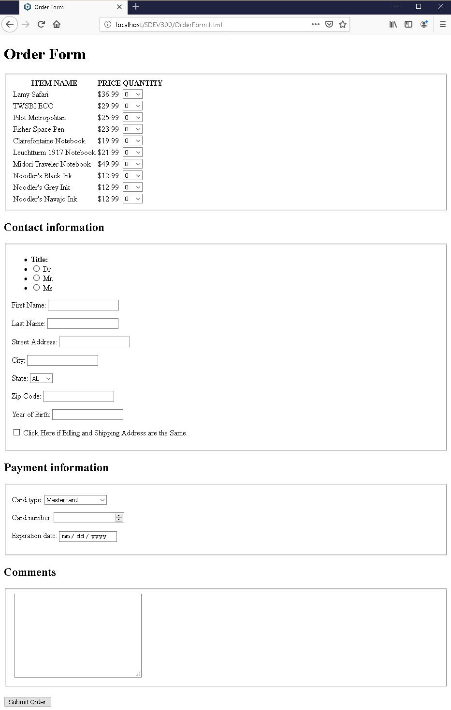

Access Log Analysis
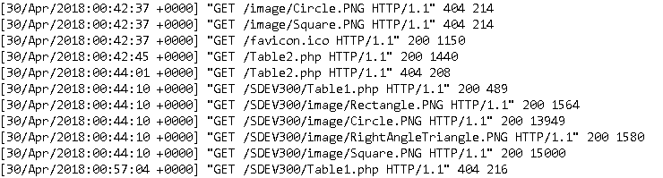
My access log is somewhat long because I worked on the website off an on over several days. The main error I came across was HTTP Status Code 404 which was returned when I incorrectly formatted the links for product pages. Other status codes I came across were 303 when nothing was modified NS 200 when everything with the request was ok,

The last entry in my Access Log reads:

This log entry shows that the favicon (small icon that often appears in the URL bar in a browser) request was ok.

